Configurator–Typical EJC Configuration

Instructions for creating a new quote.

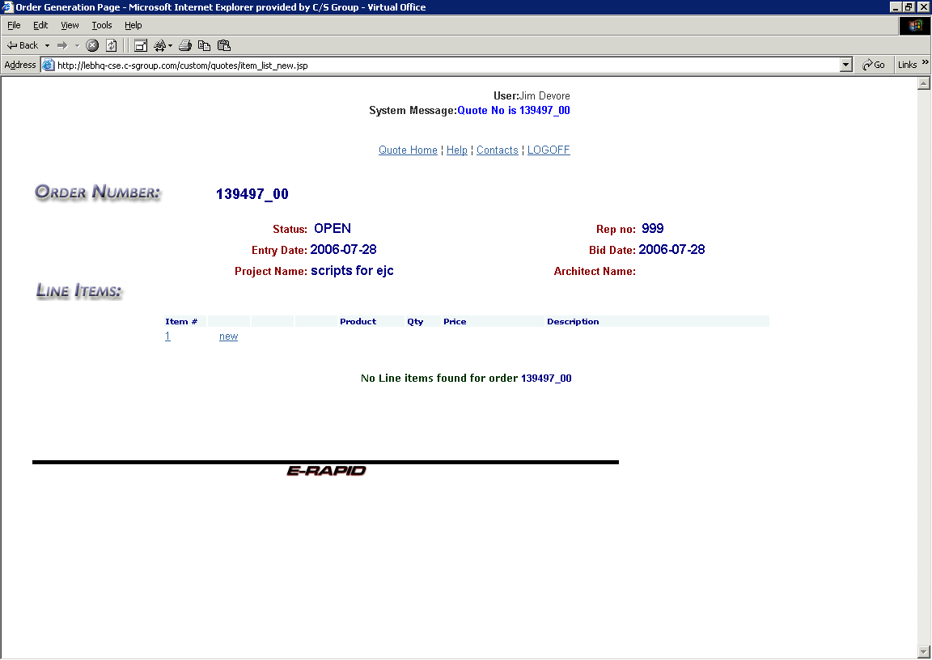

- This is the line item list. This screen directly follows the header screen. As products, or different line items are created, they are added to this list.
- Press the F11 function key to get a full screen mode.
- To return to the header screen click on the item # (number 1 in this example).
- Write down the quote number for future reference.
- Click on the blue “new” text to go to the configurator screen.

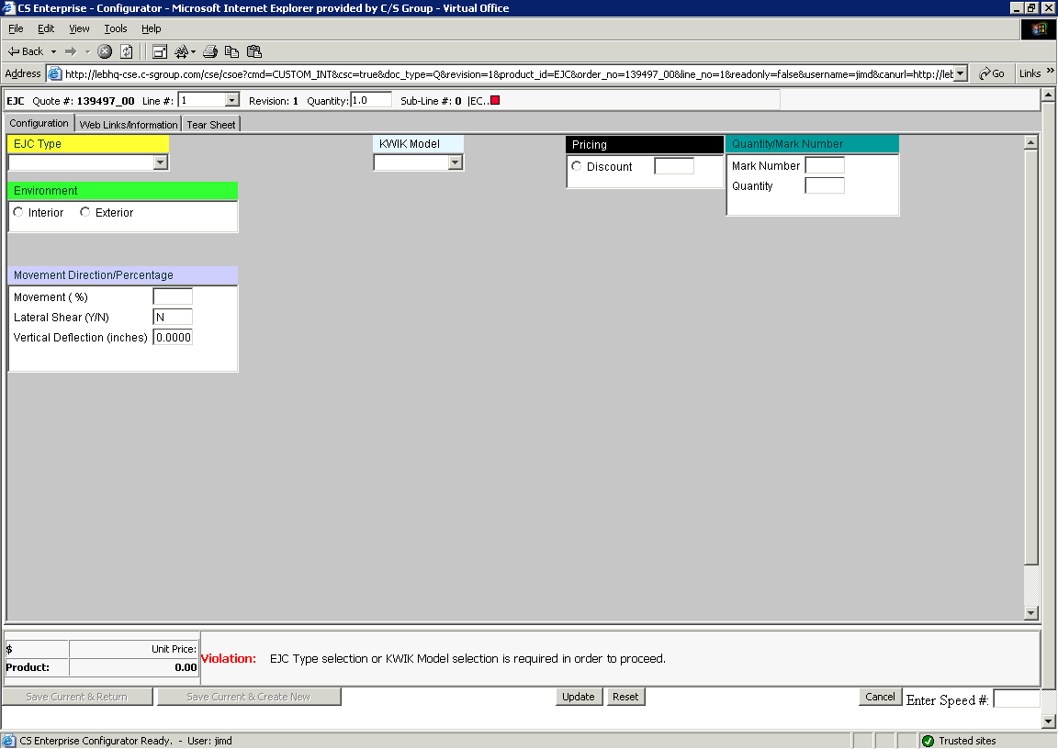

Note the three tabs at the top of the screen:
- Configuration – This is the area in which specific product information is added. For example model number, quantity etc.
- Web Links/Information – This is the screen in which product information and tear sheets can be brought in.
- Tear Sheet – This screen will preview the model selected.

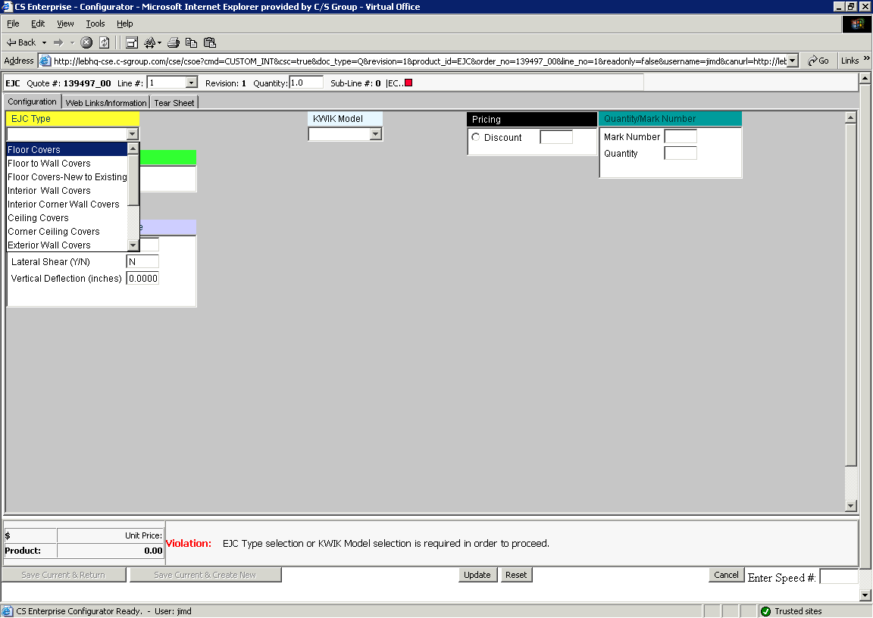

- Click on the drop down arrow at the right end of the EJC Type

- Highlight and click on one of the EJC types listed.

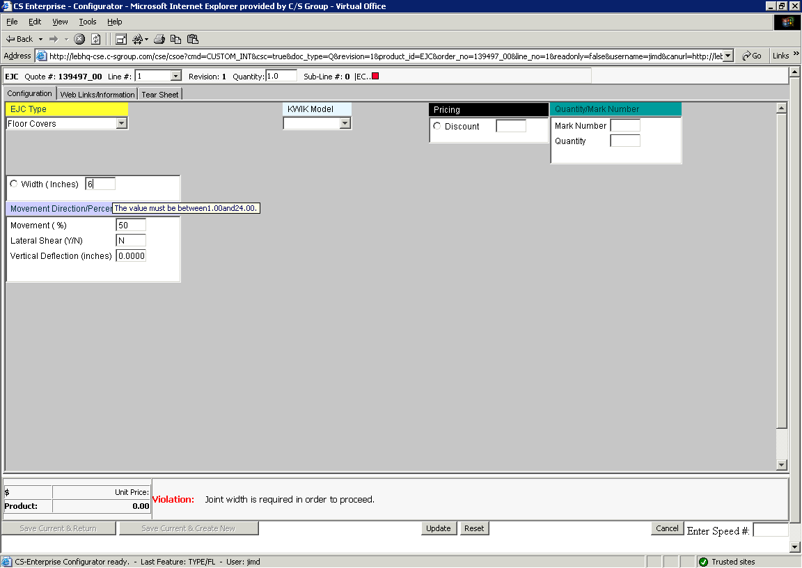

- Enter Width. Be sure to tab or click out of the entry box.
- Note the Violation box at the bottom right hand side of the screen. This is the area where violations or exceptions will appear. This box is also an instruction set to help you move through the program. Generally this box will spell out the next selection required.
- Note that as you enter the width the next selection screen will appear (you must click out of the entry box).
- Verify movement requirements. Note that default values are automatically entered for movement percentage, lateral shear and vertical deflection. Change them as required. If values entered exceed preset limits, a message will be displayed in the Violation box.

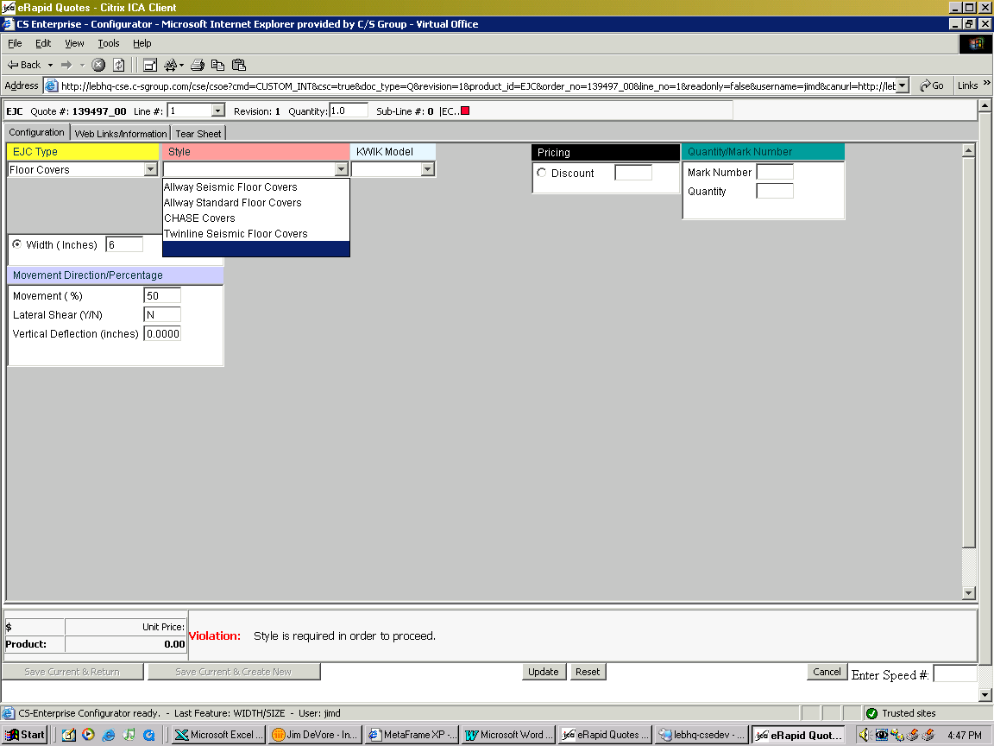

- Select style from the list of available options.
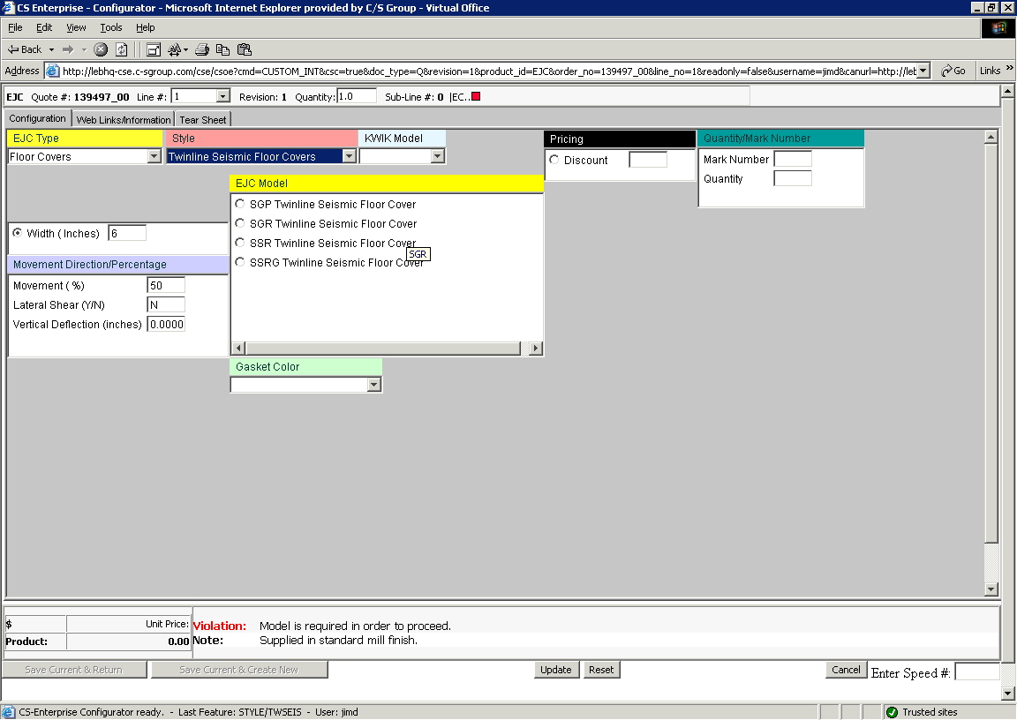

- Select from available models that meet your criteria.
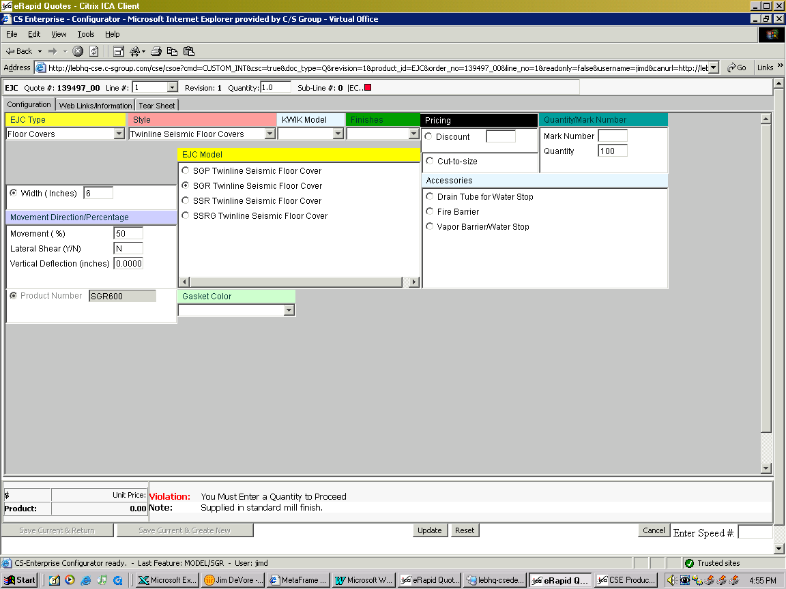

- Change the quantity required as necessary. For lineal items the unit of measure is ‘LF’.
- You may also enter a Mark Number, if known or desired.
- To correct an entry, click in the box and reenter the data
- When complete, the violation or instruction box at the lower right will disappear.
- Note that the Expansion Joint Cover model is automatically entered in the Product box.

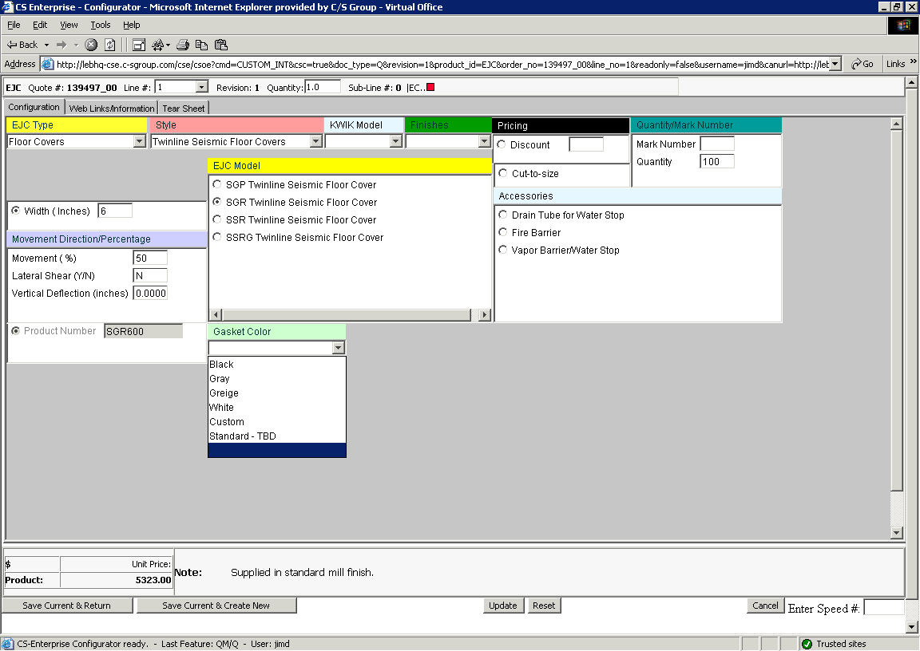

- Select a finish and/or a gasket color, if known.
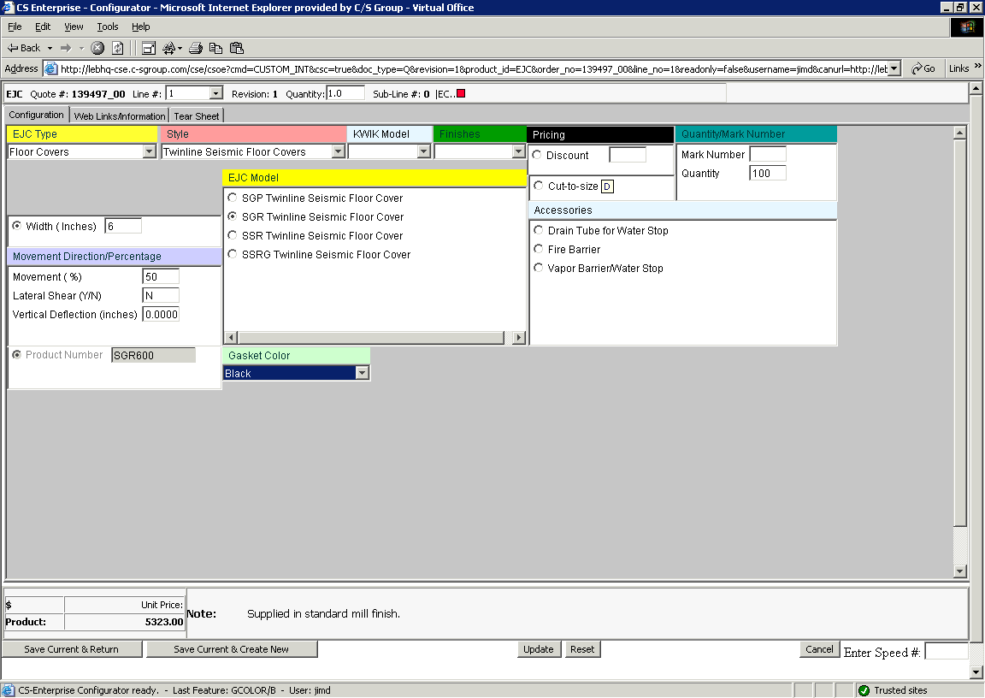

- Enter special discount percentage if available for that model.

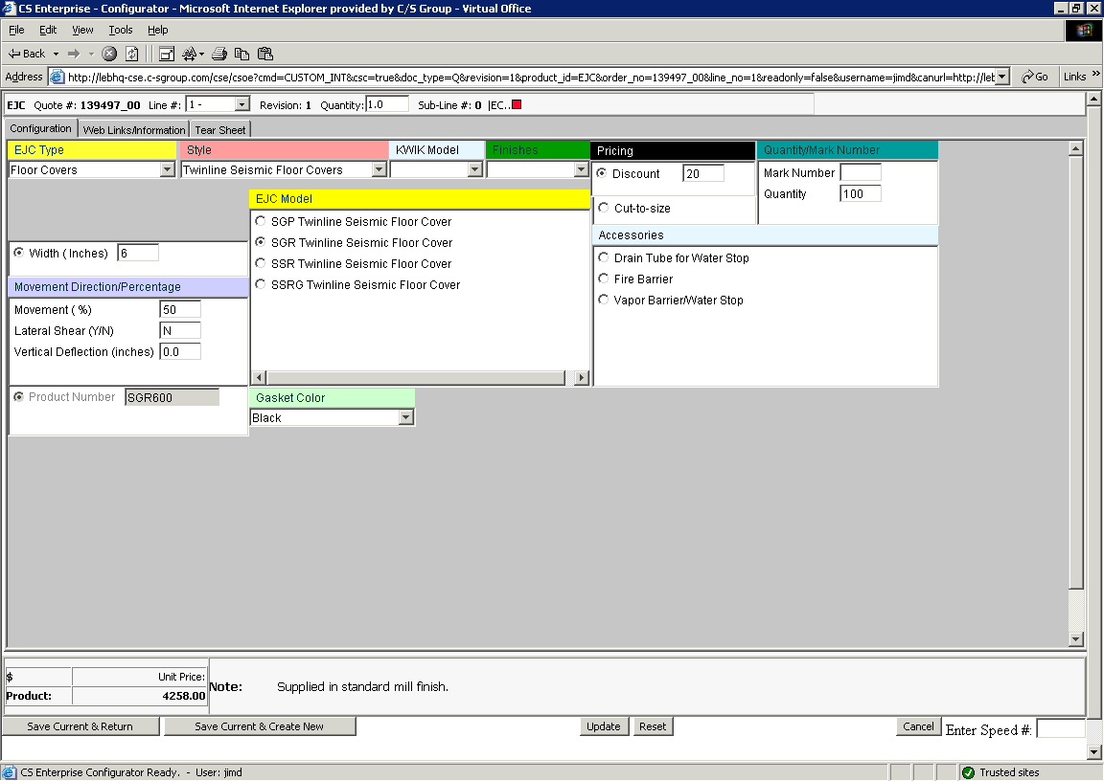
- After the configuration is complete, with no violations appearing, two options are available on the lower left:
- Save Current and Create New – Click on this to save the current configuration (model, quantity, size etc) and continue to enter additional similar configurations.
Use this option to add accessories, such as Fire Barrier, for the current item. You must select and save each accessory individually. See page 11 for instructions on adding accessories.
Be sure to hit the “Reset” button on the lower part of the screen when changing models.
The line number is incremented after each save.
- Save Current and Return – Click here to save this current configuration and return to the line item screen to complete the quote process.

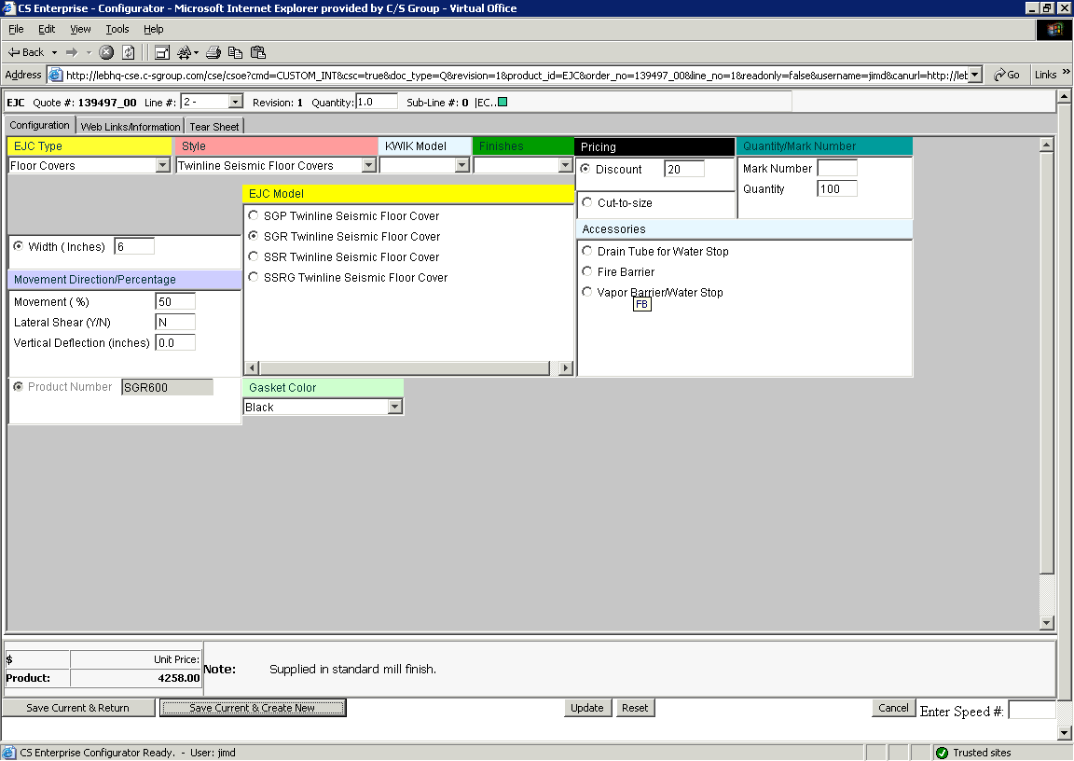
- After issuing a save current and create new, an accessory add for the model just quoted is readily available. Simply click on the options located in the Accessory box, verify your quantity, and add other information if further boxes pop up (see example following)
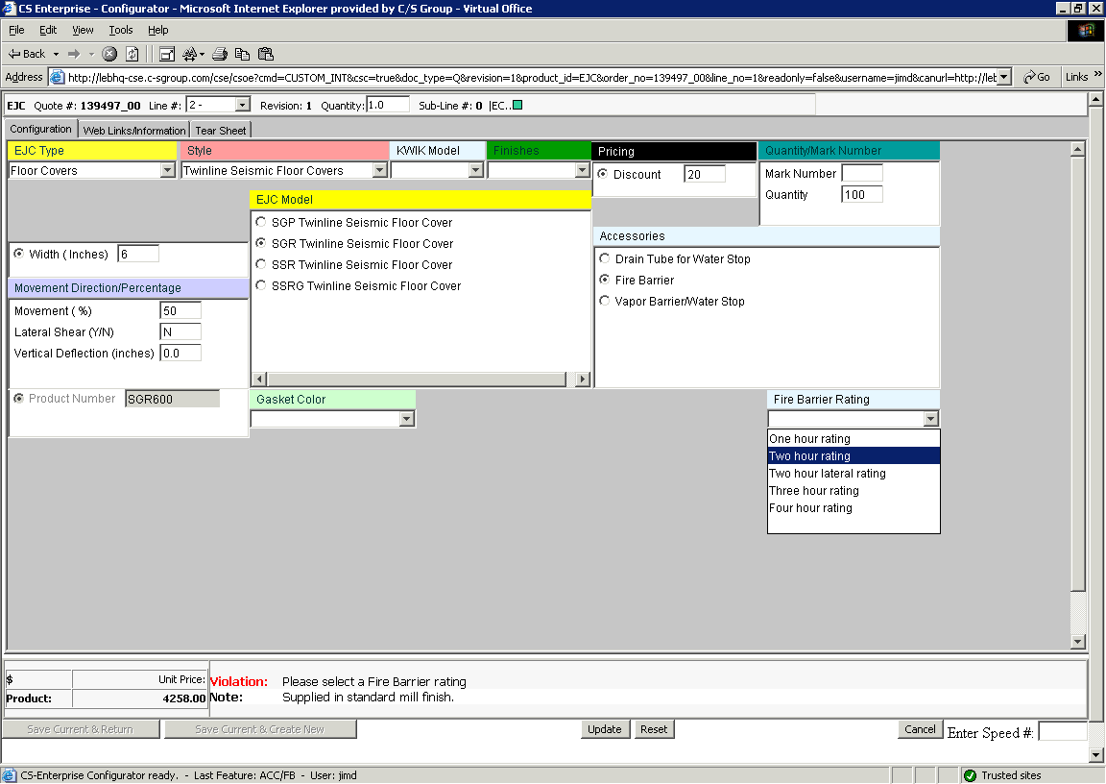
- The fire barrier accessory was chosen for this model, so a rating must be selected from the available options.
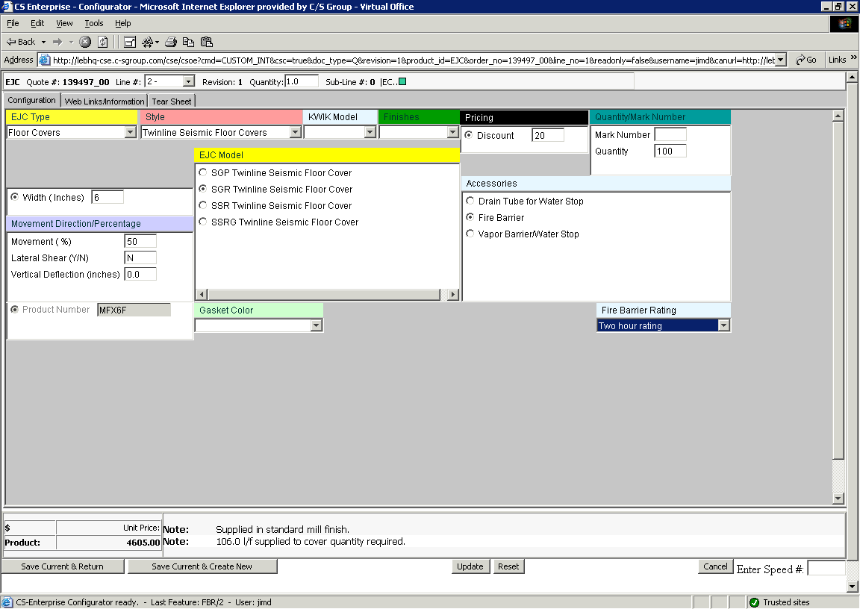
- Once selected, the product can be verified in the Product box. In the event it does not populate immediately, try the update button. If there is a conflict on availability, a notice will populate the text box in the lower center of your screen.
- Click File – Save Current and Return to return to the Line Item screen, or File - Save Current and Create New to add another product or accessory.

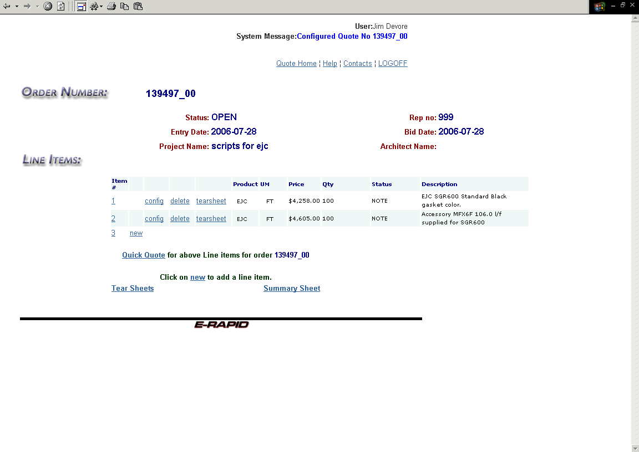
Choices for the next step:

- Click on the 1 or 2 in the “Item #” column to return to the header.
- Click on the “new” to enter a new configuration (model, quantity, size etc).
- Click on the “config” to edit an existing line or configuration.
- Click on the “Quick Quote” to continue to the calculation screen.
- Click on “tearsheet” on the line to view a single tear sheet, or “Tear Sheets” on the lower left to get all tears heets for this quote.
- Click on “delete” to remove a line from the quote – a confirmation box will appear.
- Click on “Summary Sheet” on the lower right to get a detailed summary of the quotation.

Reference Page: Error Messages

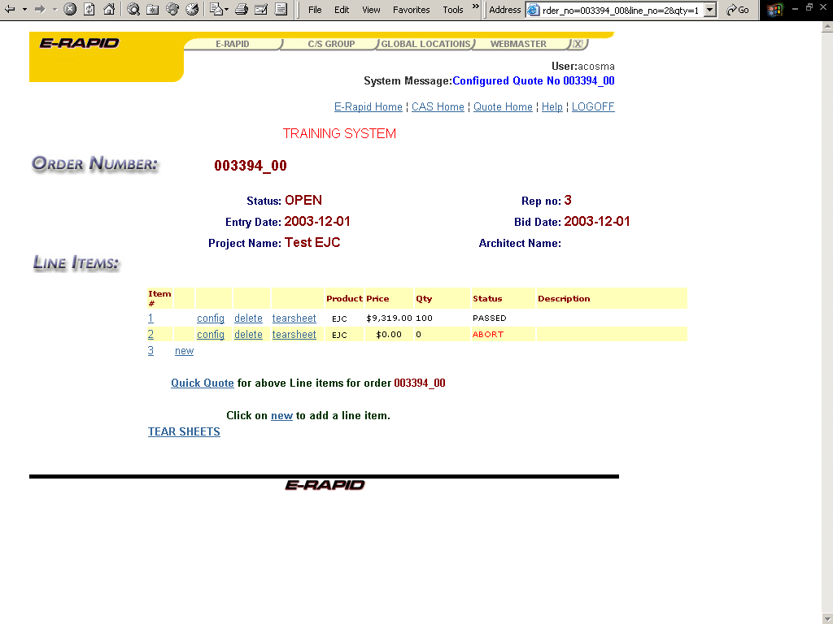

- If you see the red “Abort” error, as in line two above, the line has a major error and is not included in the quoted sale price. Aborts must be corrected before proceeding. Click on the “config” link for that line to make changes.

Reference Page: Error Messages

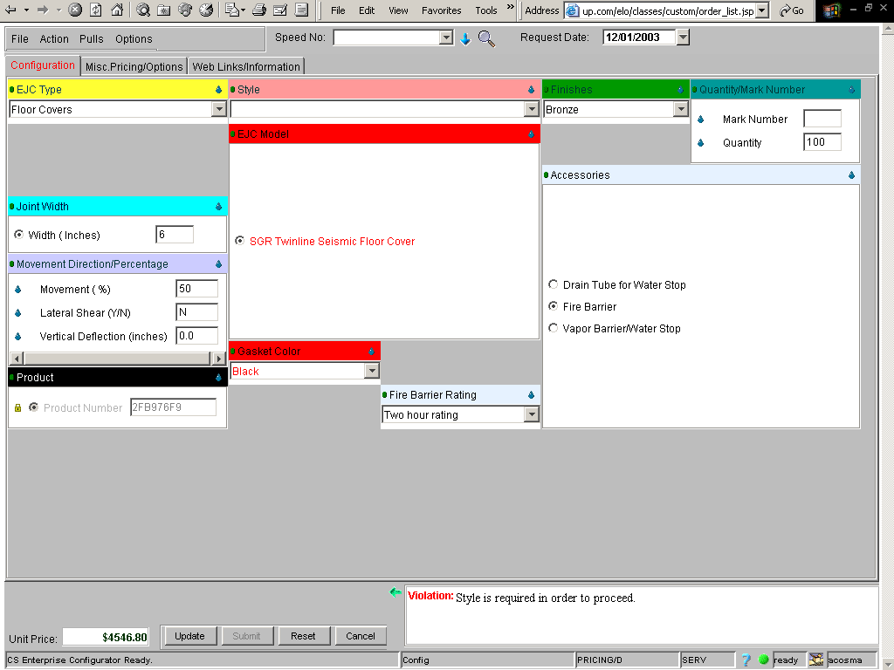

- Any red in the tab at the top or a specific block indicates an error. In the example above, the style was not selected, indicated by the violation in the message box at the bottom right. Selecting a style will fix this error.

- Often, clicking within the red block will be required to select or deselect an option to correct the “red” error. Responding to the Violation message will often also fix this error.

- If the error cannot be corrected by unselecting features, click the “Reset” button at the bottom of the page and start over.

To obtain Tearsheet or Product information:

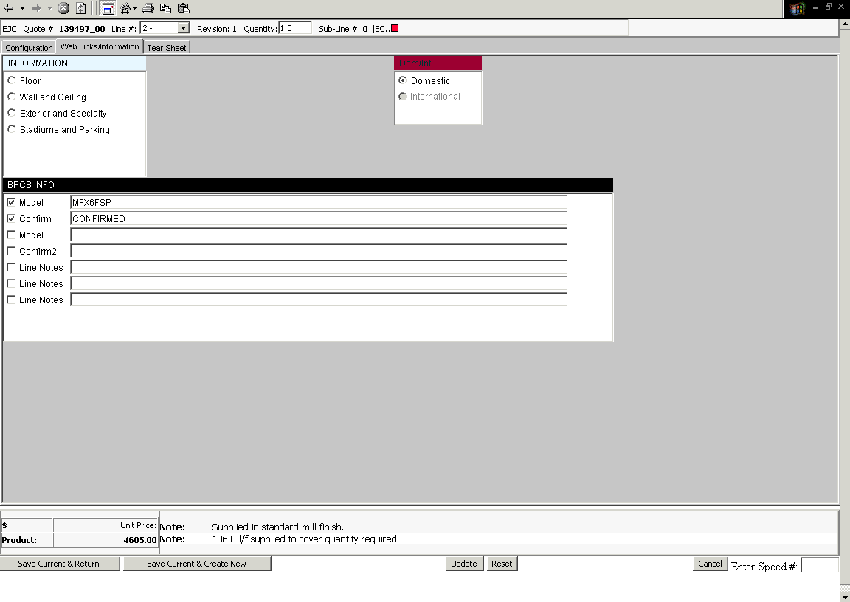

- From the configuration screen click on the third tab at the top: “Web Links/Information.”

- To obtain product information, click on the product in the “Information” block.
- You can also add specific line notes to the configured product here.

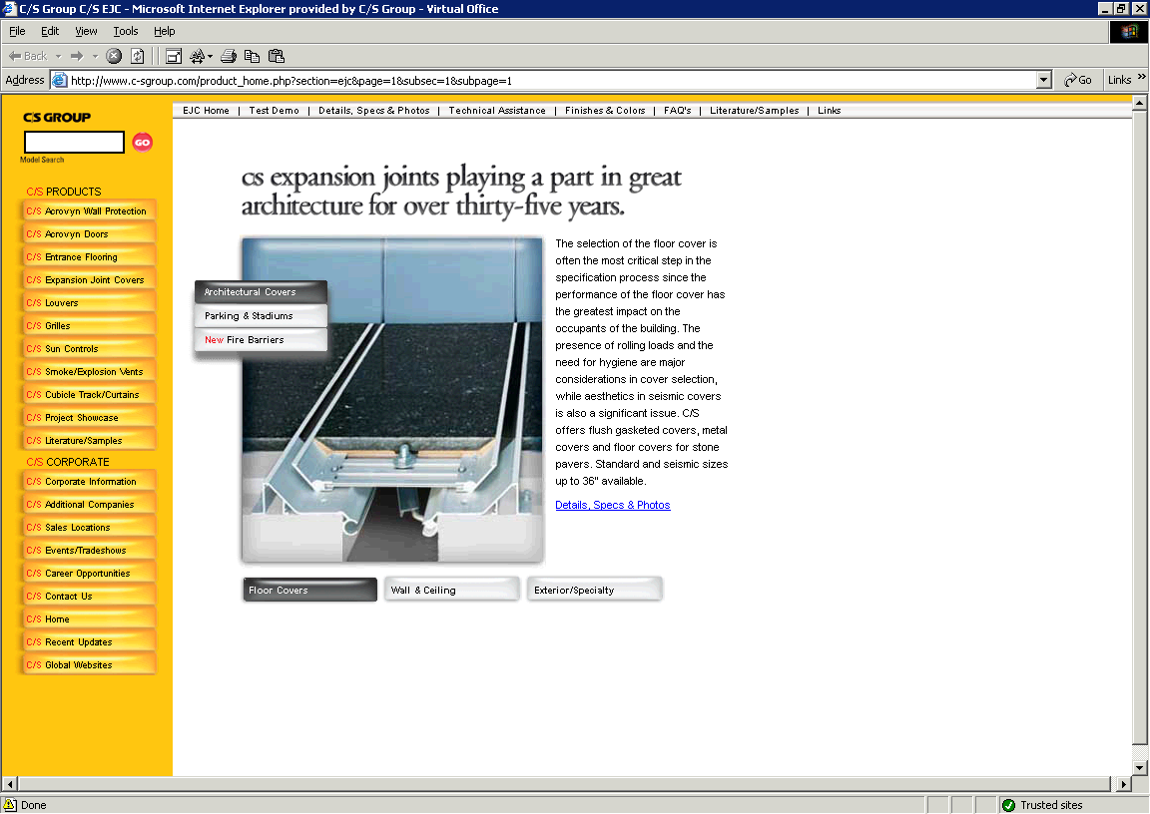

- Product information will be retrieved/linked from the C/S Website.

- Close this window to return.

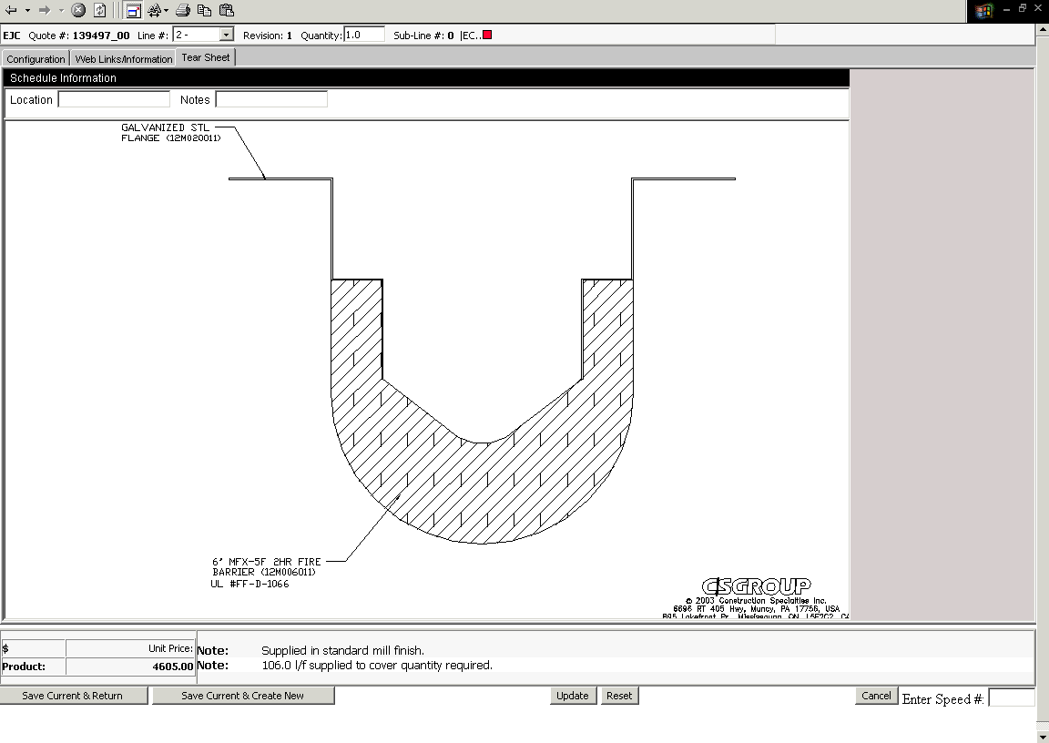
- An example of a configured model tear sheet. Full tear sheets for printing are available Line Item screen by clicking tear sheet on the order line (which will show the tear sheet for that line) or Tear Sheet located near the bottom of the screen (this will produce all configured tear sheets available).
- You can add brief test in the location and notes fields at the upper left.

End Section

